Solving Advent of Code 2019-08 with R and JavaScript.

[Disclaimer] Obviously, this post contains a big spoiler about Advent  
of Code, as it gives solutions for solving day 8.

**About the JavaScript code**

The JavaScript code has been written in the same RMarkdown as the R  
code. It runs thanks to the {bubble} package:

**Instructions**

Find the instructions at: <https://adventofcode.com/2019/day/8>

**R solution**

**Part one**

library(magrittr)

library(purrr)

ipt <- read.delim("input8.txt", header = FALSE, colClasses = "character")$V1

ipt <- strsplit(ipt, "")[[1]] %>% as.numeric()

layers_size <- 6 * 25

l <- list()

for (i in 1: (length(ipt)/layers_size)){

l[[i]] <- ipt[1:150]

ipt <- ipt[151:length(ipt)]

}

mn <- l %>%

lapply(table) %>%

map_dbl("0") %>%

which.min()

l[[mn]] %>%

table()

## .

## 0 1 2

## 7 14 129

14 * 129

## [1] 1806

**Part two**

v <- c()

for (i in seq_len(layers_size)){

idx <- map_dbl(l, i)

v[i] <- idx[idx %in% c(0,1)][1]

}

library(dplyr)

library(tidyr)

library(ggplot2)

library(tibble)

matrix(v, ncol = 6) %>%

as.data.frame() %>%

rowid_to_column() %>%

gather(key = key, value = value, V1:V6) %>%

mutate(key = gsub("V(.)", "\\1", key) %>% as.numeric()) %>%

ggplot(aes(rowid, key, fill = as.factor(value))) +

geom_tile() +

coord_fixed() +

scale_fill_viridis_d() +

scale_y_reverse()

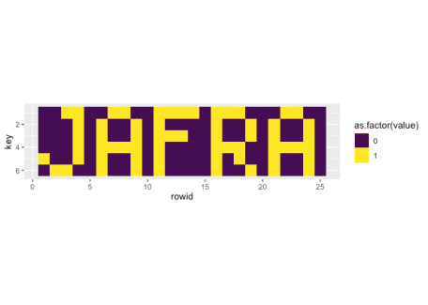

**JS solution**

var ipt = fs.readFileSync("input8.txt", 'utf8').split("").filter(x => x.length != 0 & x != '\n').map(x => parseInt(x));

var layers_size = 6 * 25;

var layer_n = ipt.length / layers_size;

var res = [];

function table(vec){

var tbl = {};

vec.map(function(x){

if (tbl[x]){

tbl[x] = tbl[x] + 1;

} else {

tbl[x] = 1;

}

})

return tbl;

}

for (var i = 0; i < layer_n; i ++){

res[i] = ipt.splice(0, layers_size);

}

var res_b = res.map(x => table(x));

var minim = Math.min.apply(Math, res_b.map(x => x['0']));

var smallest = res_b.filter(x => x['0'] == minim);

smallest[0]["1"] * smallest[0]["2"];

## 1806

var v = [];

for (var i = 0; i < layers_size; i ++){

var idx = res.map(x => x[i]);

v[i] = idx.find(z => z== 0 | z == 1);

}

var nn = [];

for (var i = 0; i < 6; i ++){

nn[i] = v.splice(0, 25).join(" ").replace(/0/g, " ");

}

nn

## [ ' 1 1 1 1 1 1 1 1 1 1 1 1 1 ',

## ' 1 1 1 1 1 1 1 1 ',

## ' 1 1 1 1 1 1 1 1 1 1 ',

## ' 1 1 1 1 1 1 1 1 1 1 1 1 1 ',

## '1 1 1 1 1 1 1 1 1 ',

## ' 1 1 1 1 1 1 1 1 1 ' ]